No-Code AI Automation- Project Report
Week 5 · Generative AI & Prompt Engineering

1. Overview
This project builds an automated workflow that triggers whenever a new response is submitted through a Google Form, sends the submission to an AI model for processing, and writes the AI's output back into the linked Google Sheet. The workflow requires no manual intervention once a form is submitted.

2. Project Summary
Trigger | New row added to a Google Sheet (populated automatically by Google Form responses)
Automation Platform | n8n (cloud, free trial tier)
AI Provider | Groq API — model: llama-3.1-8b-instant
Final Action | Update the same Google Sheet row with the AI-generated Category, Summary, and AI Reply

3. Workflow Architecture
The workflow consists of four connected nodes in n8n:
- New Feedback Row — Google Sheets Trigger node; polls the response sheet every minute for newly added rows.
- HTTP Request — sends the row's Name, Email, and Message fields to the Groq chat completions API with a prompt instructing the model to categorize the message, summarize it, and draft a reply.
- Parse AI Output — a Code node that extracts the AI's JSON response, parses it, and prepares clean category / summary / reply / email fields for each row.
- Update Sheet With AI Result — writes the parsed values back into the Category, Summary, and AI Reply columns of the matching row (matched by email address).
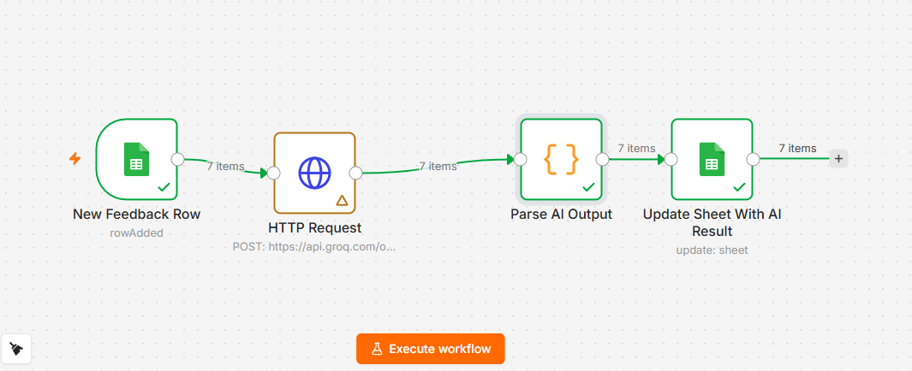
Figure 1: n8n workflow canvas showing the four connected nodes.

4. AI Prompt Used
Each row's Name, Email, and Message fields were inserted into the following prompt, sent to the Groq API:
content: "You are a customer support assistant. Read the customer's message carefully and base your answer only on what it actually says.\n\nName: " + Object.values($json)[1] + "\nEmail: " + Object.values($json)[2] + "\nMessage: \"" + Object.values($json)[3] + "\"\n\nDo the following:\n1. Category: pick the ONE category that best fits THIS specific message — Complaint (something went wrong), Question (they're asking for info), Praise (positive feedback), or Other. Do not default to Complaint unless the message actually describes a problem.\n2. Summary: one sentence describing what the customer said, in your own words.\n3. Reply: a warm, natural 2-3 sentence reply that directly addresses their specific message. Sign off as \"The Support Team\" — do not use placeholder brackets like [Your Name].\n\nReturn ONLY valid JSON with these exact keys, no markdown fences:\n{\"category\": \"<Complaint, Question, Praise, or Other — pick based on the message above>\", \"summary\": \"<your one-sentence summary>\", \"reply\": \"<your reply>\"}"

5. Test Results
The workflow was tested end-to-end with real form submissions covering three distinct message types: a complaint, a question, and a compliment. Each submission triggered the pipeline automatically, and the AI-generated results were written back into the sheet within seconds.
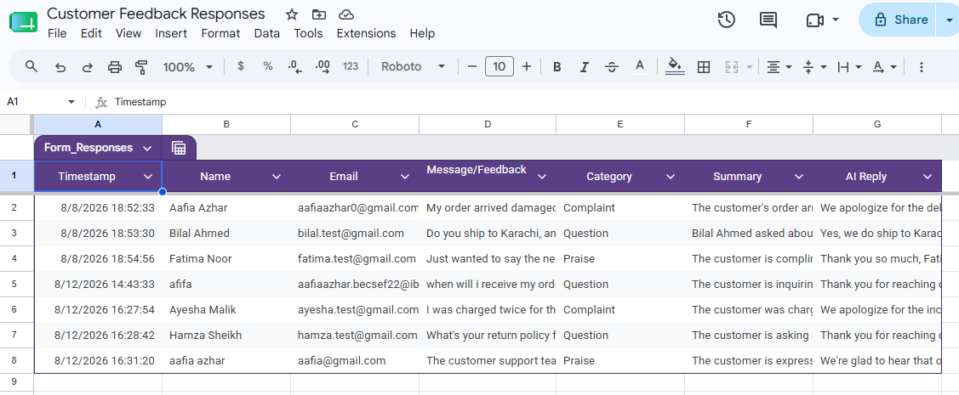
Figure 2: Google Sheet after the workflow processed multiple form submissions, showing populated Category, Summary, and AI Reply columns.

6. Challenges & Fixes
- Gemini's free-tier API returned a zero-quota error, so the AI provider was switched to Groq, which offers a genuinely free tier with no billing requirement.
- The pre-built AI action node did not support Groq directly, so a generic HTTP Request node was used to call Groq's OpenAI-compatible chat completions endpoint instead.
- The Code node initially processed only the first incoming row because it was set to "Run Once for All Items" mode; switching it to "Run Once for Each Item" fixed the workflow to process every new row.
- The sheet update step initially failed because the trigger node did not expose a row-number field; matching was changed to use the submitter's email address instead, which is guaranteed unique per test row.

7. Conclusion
The completed workflow demonstrates a full no-code automation pipeline: a real-world trigger (form submission), an AI processing step (categorization and reply drafting via Groq), and a final action that writes usable output back into a shared spreadsheet. This pattern generalizes directly to real business use cases such as auto-triaging support tickets or first-pass customer response drafting.

